**General Chemistry LabII-1112L**

# Lab Report#___7___

Andrew Kalathra, Department of Chemistry and Biochemistry, Lamar University, Beaumont TX 77710

**Title- Activation Energy Determination**

**Objective**- To show how temperature affects the rate of a reaction.

**Procedure-** 1. First we configured our LabQuest instrument by hooking up both a temperature probe and a pressure instrument.

2. Next, we filled a glass with 250 mL of normal tap water, and another glass with 250 mL of ice water.

3. Next, we got 3 4.0 mL tubes of 3% H2O2, as well as 10 mL of .5 M solution of KI (we calculated it below).

4. Finally, we started the experiment. By extracting precisely 1 mL of the KI solution, we added it to the H2O2 solution, inserted the stopper/pressure gauge, and recorded our results. These steps were replicated while our 2nd reaction tube was in the ice bath.

5. Our final reaction took place after we prepared a 300 mL glass of 40 oC water (we just added 50 mL to the tap water glass) and repeated the experiment.

**Data and Results**

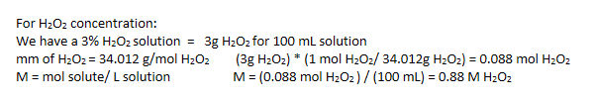

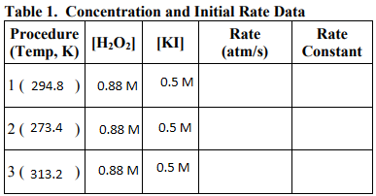

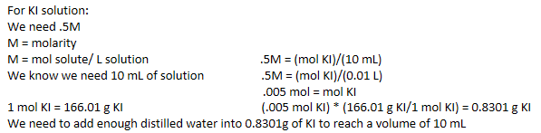

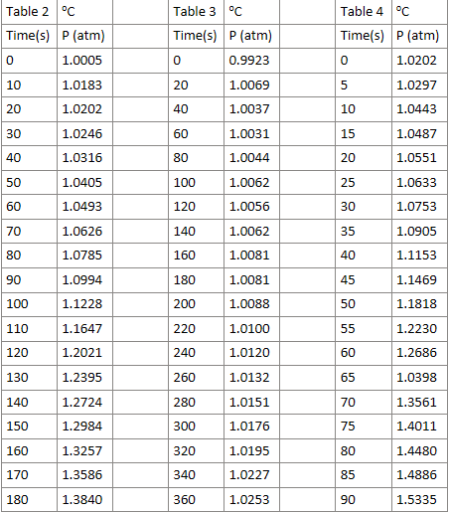

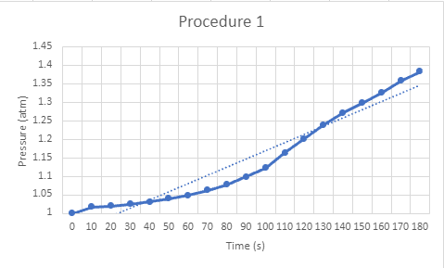

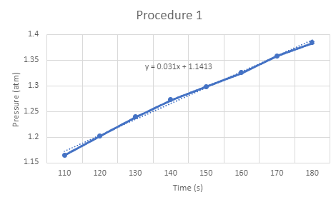

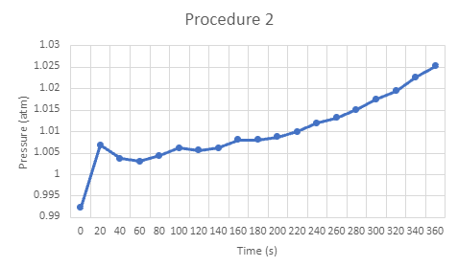

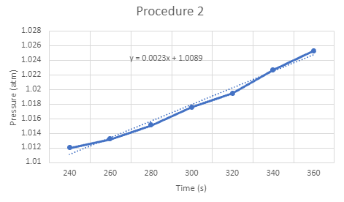

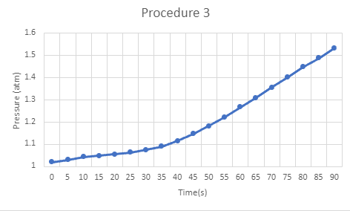

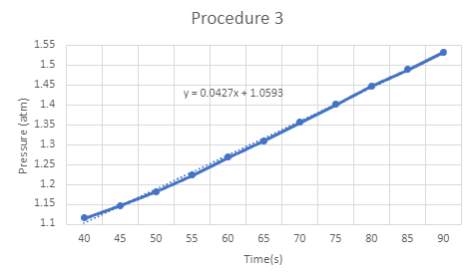

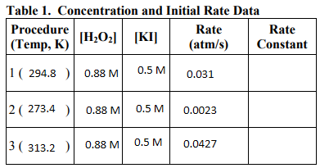

The rate law given to us:



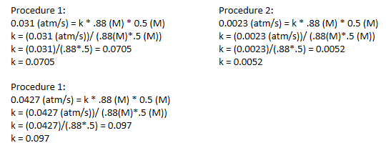

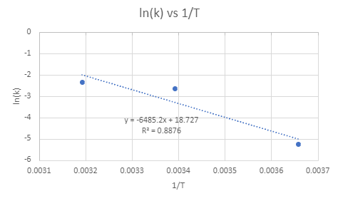

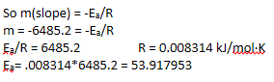

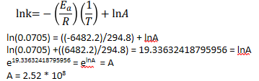

**Conclusions**

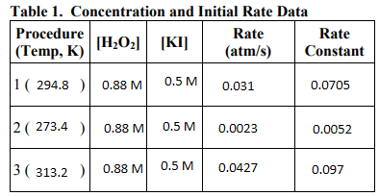

As we can see in the chart, there was a correlation between the temperature and the rate constant. We had three procedures to single out both ways the reaction could have gone away from room temperature. In the end, we plotted our results, found the slopes and used it for our calculations. We successfully observed how temperature can affect the overall pressure of the reaction.

**Key Questions-**

1. What do the equations above suggest about the order of reaction with respect to each reactant? - The hydrogen peroxide has an order of one and the potassium iodide has an order of one as well, making the reaction a second order reaction.

2. What is the overall order of reaction based on the equations above? - The overall reaction order is a section order reaction.

3. Why is there no sign in front of the change in oxygen pressure as a function of the change in time? - The final pressure of oxygen was higher then the initial pressure of oxygen, and the pressure cannot go negative.

4. What should be the effect on the rate constant k by decreasing the temperature of a reaction? - k would decrease with a decrease in temperature.

5. What should be the effect on the reaction rate by decreasing the temperature of a reaction? - The rate would also decrease with a decrease in temperature.

6. Should the A term in the Arrhenius equation be affected by changes in temperature? - Since temperature is part of the Arrhenius equation, I would assume yes.

7. Which term of the linearized Arrhenius equation represents the y-value? - lnk

8. Which term of the linearized Arrhenius equation represents the x-value? - (1/T)

9. Which term of the linearized Arrhenius equation represents the slope, m? - - Ea/R

10. Which term of the linearized Arrhenius equation represents the intercept, b? - lnA

11. Determine the activation energy and the frequency factor for the KI catalyzed decomposition reaction of H2O2. -





* Do not forget to attach the signed lab work-out
* 